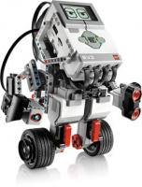

**This Certifies that you have Successfully demonstrated the robotic behavior**

**Touch and Release**

April 2014

Josh and Jose.

J. J. Co.

Congratulations!

**Jessicarae Nuñez**

**Rich Bakala**